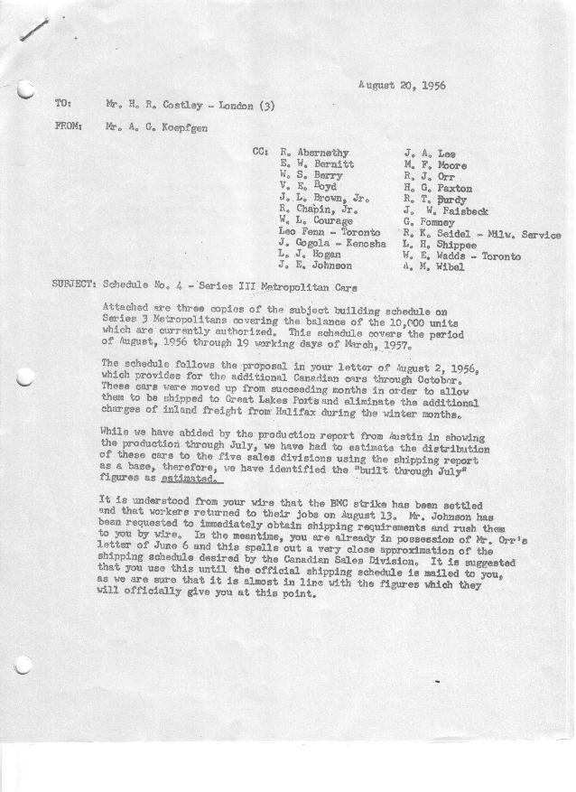

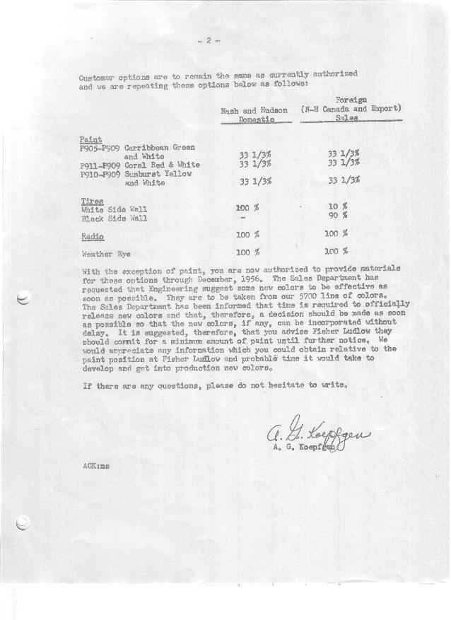

FORM PLAN 68 REV. 2-55-A.M.P Sheet1 of 2 APPROVED R. Abernethy (signed) DATE 8-17-56

SCHEDULE NO. ______4 ________ DATE 8/ 17 /56 MONTHLY BUILDING SCHEDULE APPROVED R.T. Purdy (signed)_ DATE_ 8-20-56 ____
REVISION NO. _______ _______ DATE PRODUCT APPROVED_E. W. Bernitt (signed) ___ __DATE _ 8-20-56 ____
SERIES III 1500 c.c. ENGINE
METROPOLITAN SERIES CARS – AUSTIN MTRS. CO., LTD, ENGLAND
DESCRIPTION | BUILT  ◻ACT EST  THRU  July | FIRM BUILDING SCHEDULE  (FABRICATED MATERIAL RELEASE) |  |  |  |  |  |  |  |  |  |  |  |  |  |  | TENTATIVE SCHEDULE  (RAW MATERIAL RELEASED) |  |  | GRAND  TOTAL
DESCRIPTION | BUILT  ◻ACT EST  THRU  July | MONTH Aug  DAYS 15 |  |  | MONTH Sept  DAYS 20 |  |  | MONTH Oct.  DAYS 23 |  |  | MONTH Nov.  DAYS 22 |  |  | MONTH Dec.  DAYS 18 |  |  |  |  |  | GRAND  TOTAL
DESCRIPTION | BUILT  ◻ACT EST  THRU  July | DAILY | MONTH | CUM’L  TOTAL | DAILY | MONTH | CUM’L  TOTAL | DAILY | MONTH | CUM’L  TOTAL | DAILY | MONTH | CUM’L  TOTAL | DAILY | MONTH | CUM’L  TOTAL | DAILY | MONTH | CUM’L TOTAL | GRAND  TOTAL
DOMESTIC:
Hard-Top | 3849 |  | 305 | 4154 |  | 601 | 4755 |  | 545 | 5300 |  | 520 | 5820 |  | 422 | 6242
Soft-Top | 541 |  | 0 | 541 |  | 0 | 541 |  | 0 | 541 |  | 0 | 541 |  | 0 | 541
Total U.S. | 4390 |  | 305 | 4695 |  | 601 | 5296 |  | 545 | 5841 |  | 520 | 6361 |  | 422 | 6783
Over/(Under) Sched. No.3 | (220) |  | 62 | (158) |  | 161 | 3 |  | -0- | 3 |  | (5) | (2) |  | 6 | 4
FOREIGN:
EXPORT Hard-Top | 302 |  | 67 | 369 |  | 55 | 424 |  | 93 | 517 |  | 29 | 546 |  | 31 | 577
Soft-Top | 210 |  | 0 | 210 |  | 0 | 210 |  | 0 | 210 |  | 0 | 210 |  | 0 | 210
Total Export | 512 |  | 67 | 579 |  | 55 | 634 |  | 93 | 727 |  | 20 | 756 |  | 31 | 787
Over/(Under) Sched. No.3 | (58) |  | 0 | (58) |  | 5 | (53) |  | 53 | 0 |  | (1) | (1) |  | 1 | 1
CANADA NASH Hard-Top | 66 |  | 119 | 185 |  | 125 | 310 |  | 145 | 455 |  | 17 | 472 |  | 28 | 500
Soft-Top | 15 |  | 0 | 15 |  | 0 | 15 |  | 0 | 15 |  | 0 | 15 |  | 0 | 15
Total Nash-Canada | 81 |  | 119 | 200 |  | 125 | 325 |  | 145 | 470 |  | 17 | 487 |  | 28 | 515
Over/(Under) Sched. No.3 | (19) |  | 19 | 0 |  | 45 | 45 |  | 70 | 115 |  | (58) | 57 |  | (72) | (15)
HUDSON Hard Top | 21 |  | 49 | 70 |  | 59 | 129 |  | 68 | 197 |  | 6 | 203 |  | 5 | 208
Soft Top | 10 |  | 0 | 10 |  | 0 | 10 |  | 0 | 10 |  | 0 | 10 |  | 0 | 10
Total Hudson Canada | 31 |  | 49 | 80 |  | 59 | 139 |  | 68 | 207 |  | 6 | 213 |  | 5 | 218
Over/(Under) Sched. No.3 | (9) |  | 9 | 0 |  | 29 | 29 |  | 38 | 67 |  | (24) | 43 |  | (25) | 18
TOTAL FOREIGN | 624 |  | 235 | 859 |  | 239 | 1098 |  | 306 | 1404 |  | 52 | 1456 |  | 64 | 1520
Over/(Under) Sched. No.3 | (86) |  | 28 | (58) |  | 79 | 21 |  | 161 | 182 |  | (83) | 99 |  | (96) | 3
GRAND TOTALS
Hard-Top | 4238 | 36 | 540 | 4778 | 42 | 840 | 5618 | 37 | 851 | 6469 | 26 | 572 | 7041 | 27 | 486 | 7527
Soft-Top | 776 | 0 | 0 | 776 | 0 | 0 | 776 |  | 0 | 776 |  | 0 | 776 |  | 0 | 776
Total | 5014 | 36 | 540 | 5554 | 42 | 840 | 6394 | 37 | 851 | 7245 | 26 | 572 | 7817 | 27 | 486 | 8303
Over/(Under) Sched. No.3 | (306) |  | 90 | (216) |  | 240 | 24 |  | 161 | 185 |  | (88) | 97 |  | (90) | 7

FORM PLAN 68 REV. 2-55-A.M.P Sheet2 of 2 APPROVED R. Abernethy (signed) DATE 8-17-56

SCHEDULE NO. ______4 Contd.___ DATE 8/ 17 /56 MONTHLY BUILDING SCHEDULE APPROVED R.T. Purdy (signed)_ DATE_ 8-20-56 ____
REVISION NO. _______ _______ DATE PRODUCT APPROVED_E. W. Bernitt (signed) ___ __DATE _ 8-20-56 ____
SERIES III 1500 c.c. ENGINE
METROPOLITAN SERIES CARS – AUSTIN MTRS. CO., LTD, ENGLAND
DESCRIPTION | BUILT  ◻ACT EST  THRU | FIRM BUILDING SCHEDULE  (FABRICATED MATERIAL RELEASE) |  |  |  |  |  |  |  |  |  |  |  |  |  |  | TENTATIVE SCHEDULE  (RAW MATERIAL RELEASED) |  |  | GRAND  TOTAL
DESCRIPTION | BUILT  ◻ACT EST  THRU | MONTH Jan.  DAYS 22 |  |  | MONTH Feb.  DAYS 20 |  |  | MONTH March  DAYS 19 Finish |  |  | MONTH  DAYS |  |  | MONTH  DAYS |  |  |  |  |  | GRAND  TOTAL
DESCRIPTION | BUILT  ◻ACT EST  THRU | DAILY | MONTH | CUM’L  TOTAL | DAILY | MONTH | CUM’L  TOTAL | DAILY | MONTH | CUM’L  TOTAL | DAILY | MONTH | CUM’L  TOTAL | DAILY | MONTH | CUM’L  TOTAL | DAILY | MONTH | CUM’L TOTAL | GRAND  TOTAL
DOMESTIC:
Hard-Top |  |  | 551 | 6793 |  | 381 | 7174 |  | 122 | 7296
Soft-Top |  |  | 0 | 541 |  | 83 | 624 |  | 52 | 676
Total U.S. |  |  | 551 | 7334 |  | 464 | 7798 |  | 174 | 7972
Over/(Under) Sched. No.3 |  |  | (3) | 1 |  | (1) | 0 |  | 0 | 0
FOREIGN:
EXPORT Hard-Top |  |  | 0 | 577 |  | 0 | 577 |  | 0 | 577
Soft-Top |  |  | 0 | 210 |  | 0 | 210 |  | 0 | 210
Total Export |  |  | 0 | 787 |  | 0 | 787 |  | 0 | 787
Over/(Under) Sched. No.3 |  |  | 0 | 0 |  | 0 | 0 |  | 0 | 0
CANADA NASH Hard-Top |  |  | 25 | 525 |  | 50 | 575 |  | 213 | 788
Soft-Top |  |  | 15 | 30 |  | 3 | 33 |  | 23 | 56
Total Nash-Canada |  |  | 40 | 555 |  | 53 | 608 |  | 236 | 844
Over/(Under) Sched. No.3 |  |  | (60) | (75) |  | (47) | (122) |  | 122 | 0
HUDSON Hard Top |  |  | 15 | 223 |  | 37 | 260 |  | 114 | 374
Soft Top |  |  | 3 | 13 |  | 3 | 16 |  | 7 | 23
Total Hudson Canada |  |  | 18 | 236 |  | 40 | 276 |  | 121 | 397
Over/(Under) Sched. No.3 |  |  | (32) | (14) |  | (35) | (49) |  | 49 | 0
TOTAL FOREIGN |  |  | 58 | 1578 |  | 93 | 1671 |  | 357 | 2028
Over/(Under) Sched. No.3 |  |  | (92) | (89) |  | (82) | (171) |  | 171 | 0
GRAND TOTALS
Hard-Top |  |  | 591 | 8118 |  | 468 | 8586 |  | 449 | 9035
Soft-Top |  |  | 18 | 794 |  | 89 | 883 |  | 82 | 965
Total |  | 28 | 609 | 8912 | 28 | 557 | 9469 |  | 531 | 10000
Over/(Under) Sched. No.3 |  |  | (95) | (88) |  | (83) | 171  ( (171)?) |  | 171 | 0

